**REVIEW QUESTIONS – 3.2.1 h,i - Functional Ecosystems: Keystone Species – ANSWERS**

1. **PA MOCKEXAM SA PAPER 2 (3.2.1 i)**

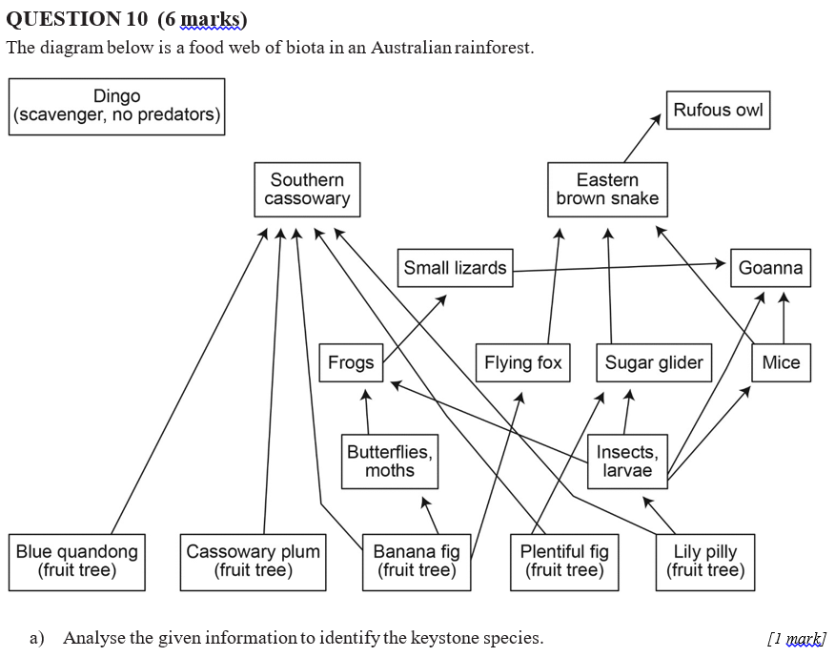

The Southern Cassowary



Ecosystem collapse. Cassowaries consume, disperse and help germinate the seeds of significant fruiting trees, the loss of cassowaries would effectively prevent germination of these important trees. As a result forest diversity would be significantly reduced and other consumers reliant on these species would consequently be effected.

1. **SCHOOL ONLY MOCKEXAM SA PAPER 2 (3.2.1 h)**

**QUESTION 3 (2 marks)**

Identify two roles that keystone species play in maintaining the structure of a community.

They may act to maintain biodiversity and control populations.

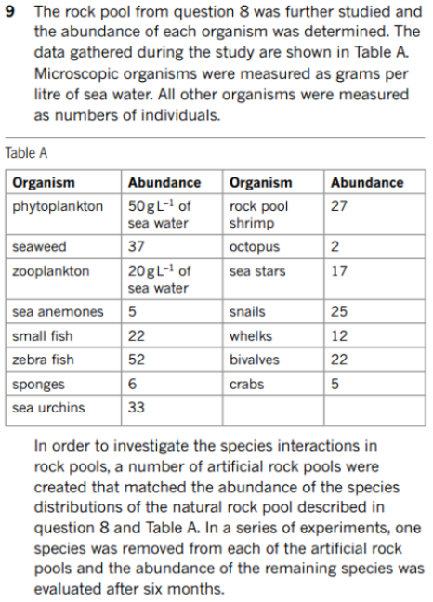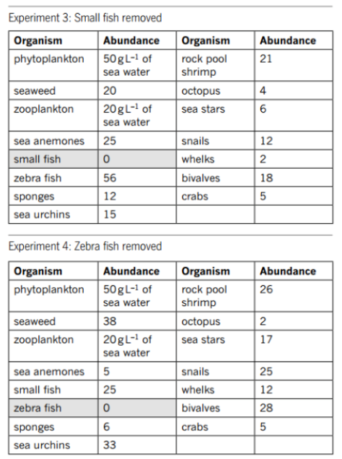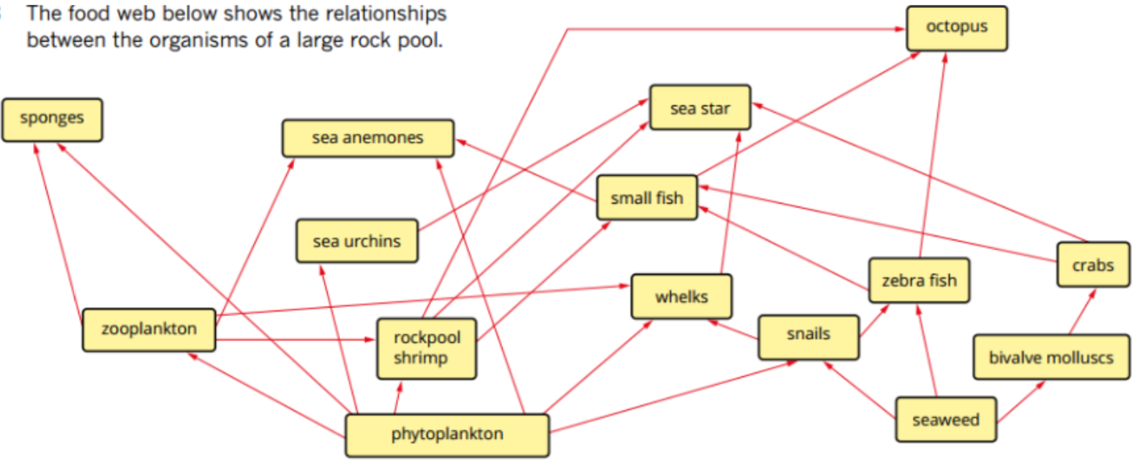

|  |
| --- |
| Small fish. The abundance of more species were affected when the small fish were removed than the removal of any other species. |

1. 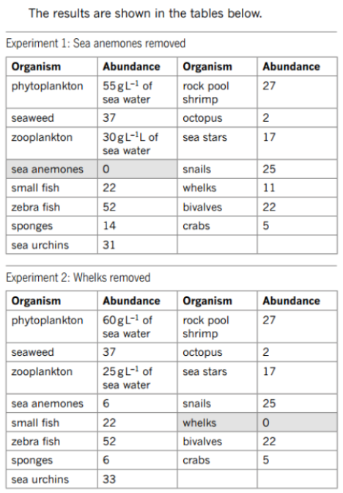 **Analyse** the given information to **identify** which species if any is a keystone species. Briefly **justify** your choice. (3.2.1 i) [2]

|  |
| --- |
| The loss of small fish would result in a reduction in productivity, as well as a reduction in diversity and abundance of organisms in this ecosystem. This is supported by the data provided which shows a net reduction in the abundance of most organisms within the system including a reduction in the abundance of a significant producer in the form of seaweed. |

1. **Predict** the outcome for the ecosystem of removing the keystone species. Give a reason. (3.2.1 i) [2]